**DAILY ONLINE ACTIVITIES SUMMARY**

|  |  |  |  |  |  |  |  |  |
| --- | --- | --- | --- | --- | --- | --- | --- | --- |
| **Date:** | 23/05/2020 | | | | | **Name:** | Anix Jugal D’Cunha | |
| **Sem & Sec** | VIII,A sec | | | | | **USN:** | 4al16cs013 | |
| **Online Test Summary** | | | | | | | | |
| **Subject** | | --- | | | | | | |
| **Max. Marks** | |  | | **Score** | | |  | |
| **Certification Course Summary** | | | | | | | | |
| **Course** | The Complete 2020 PHP Full Stack Web Developer Bootcamp ( ongoing ) | | | | | | | |
| **Certificate Provider** | | | Udemy | | **Duration** | | | 49 hours |
| **Coding Challenges** | | | | | | | | |
| **Problem Statement:** Program to reverse a string without using String inbuilt function. | | | | | | | | |
| **Status:** Completed. | | | | | | | | |
| **Uploaded the report in Github** | | | | | yes | | | |
| **If yes Repository name** | | | | | dcunhaanixjugal | | | |
| **Uploaded the report in slack** | | | | | Yes. | | | |

Online Test Details: (Attach the snapshot and briefly write the report for the same)

Not Coducted.

Certification Course Details: (Attach the snapshot and briefly write the report for the same)

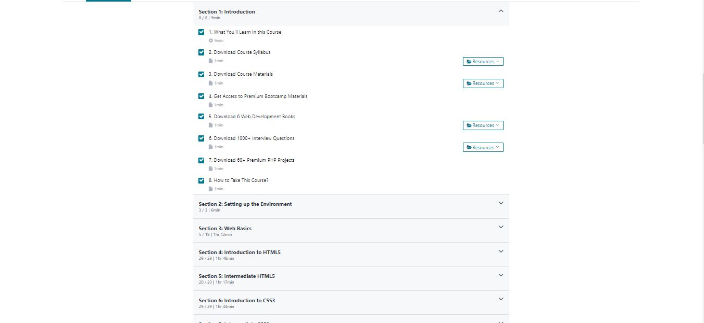

Coding Challenges Details: (Attach the snapshot and briefly write the report for the same)

Write a Java Program to reverse a string without using String inbuilt function.

public class FinalReverseWithoutUsingStringMethods {

public static void main(String[] args) {

String str = "Automation";

StringBuilder str2 = new StringBuilder();

str2.append(str);

str2 = str2.reverse(); // used string builder to reverse

System.out.println(str2);

}

}